Solar Car Challenge
Rollbar Worksheet
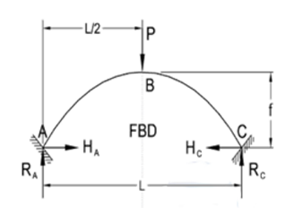
Warning: Information will be verified at scrutineering. Cars weighing more then the listed value or not matching the given information will be disqualified.
- Mass of the vehicle (m) ____________ Kg
- Roll Bar Height (f) ____________ m
- Roll Bar Width (L) ____________ m
- Roll Bar Outside Diameter (D) ____________ m
- Roll Bar Wall Thickness (t) ____________ m
- Material Type ____________
- Yield Strength ____________MPa

Step One
Calculate 5G Load

- Load (P) $P=5*9.8 \frac{m}{s^{2}}*m$ ____________ N

Step Two
Calculate Moment of Inertia for tube
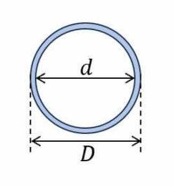
- Roll Bar inner diameter (d) $d=D-(2*t)$ _____________ m
- Moment of Inertia (I) $I=\frac{\left(D^{4}-d^{4}\right)*π}{64}$ ______________ m⁴

Step Three
Calculate Reaction Forces and Moments
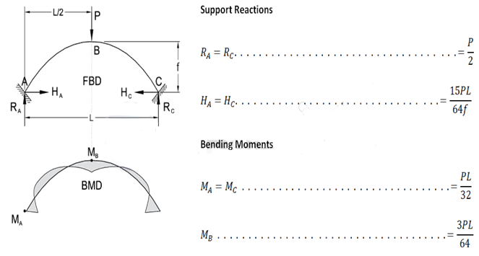
- Vertical Reaction Force (R_{a}) ___________N
- Horizontal Reaction Force (H_{a}) ___________N
- Peak Moment (M_{B}) ___________N*m

Step Four
Calculate Resulting stress

- Bending Stress (σ_{b}) $σ_{b}=\frac{M_{B}*\frac{D}{2}}{I}$ __________ MPa
- Sheer Stress (σ_{s}) $σ_{s}=\frac{H_{a}}{π\left({\left(\frac{D}{2}\right)}^{2}-{\left(\frac{d}{2}\right)}^{2}\right)}$ __________ MPa

Step Five
Determine Suitability

$$\frac{ }{Bending Stress (σb)[Line 14]} \& \frac{ }{ Sheer Stress \left(σs\right)[Line 15]} < \frac{ }{Yield Strength [Line 7]}$$

I certify that the information presented is accurate and I believe the material selection meets the requirements of the rules and is appropriate for driver safety.

_____________________________ ______________________________
Team Captain Sponsor

